Lab 0: Introduction to Network Protocols Using Python Sockets

Part 0: Verify Python Is Installed
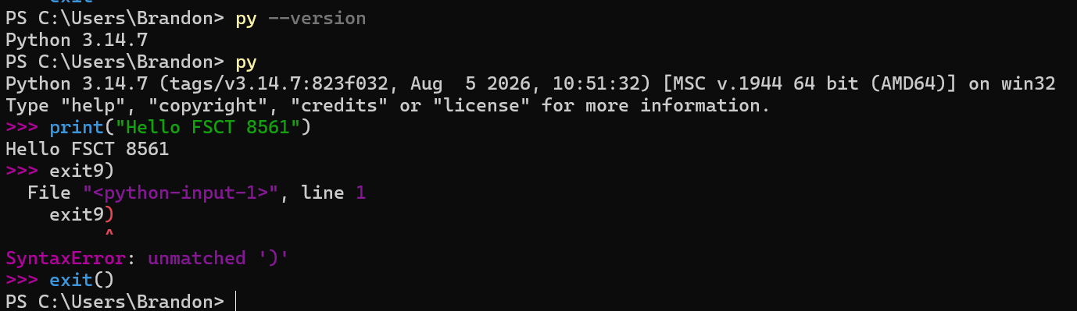

Part 1: Your First Python Program
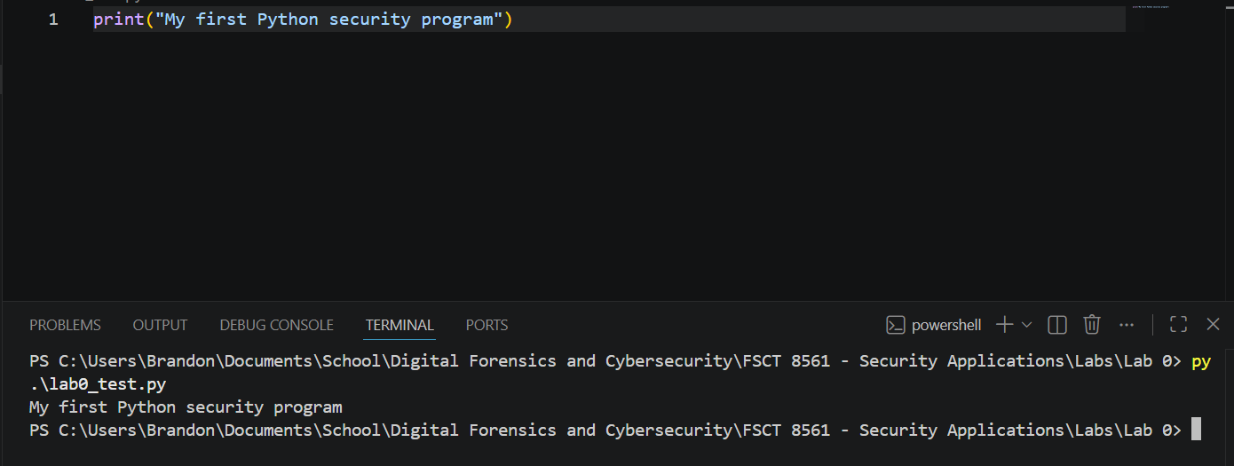

Part 2 — Understanding Sockets

Reflection Questions
- What is a Socket
A socket is a solution for an application to communicate over a network, typically to other devices.
- What does `AF_INET` mean?
AF_INET specifies that the socket should use IPv4 when communicating over the network
- What does `SOCK_STREAM` mean?
SOCK_STREAM specifies that the socket should use a TCP connection when communicating over the network

Part 4 — Create a Basic TCP Server
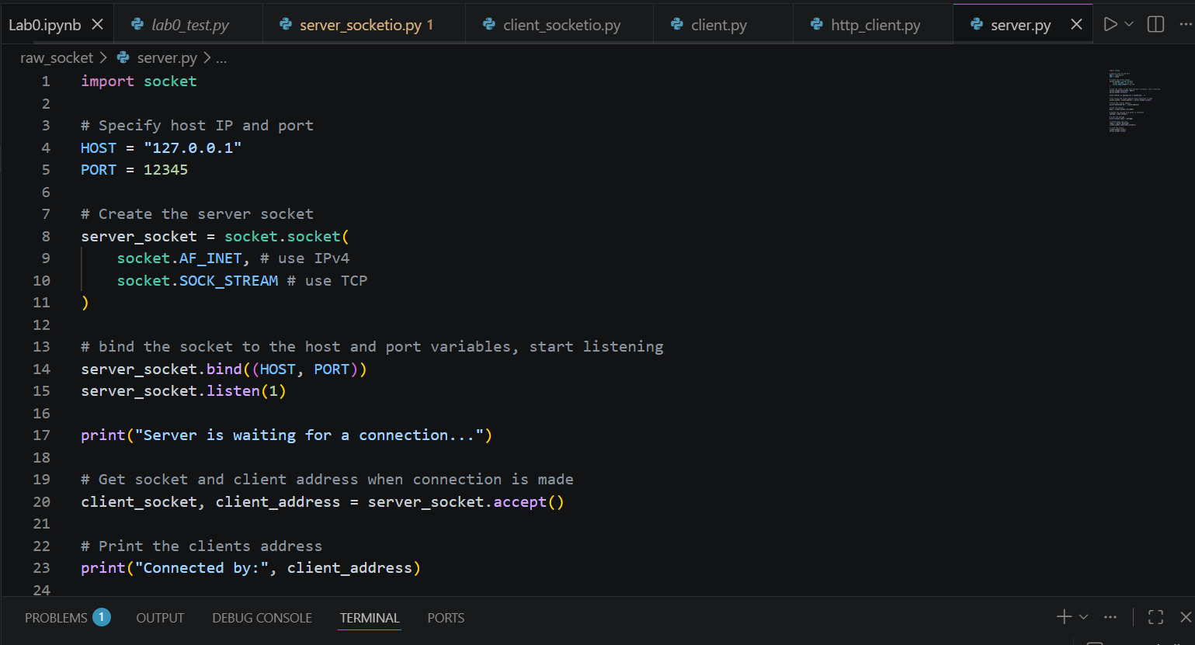
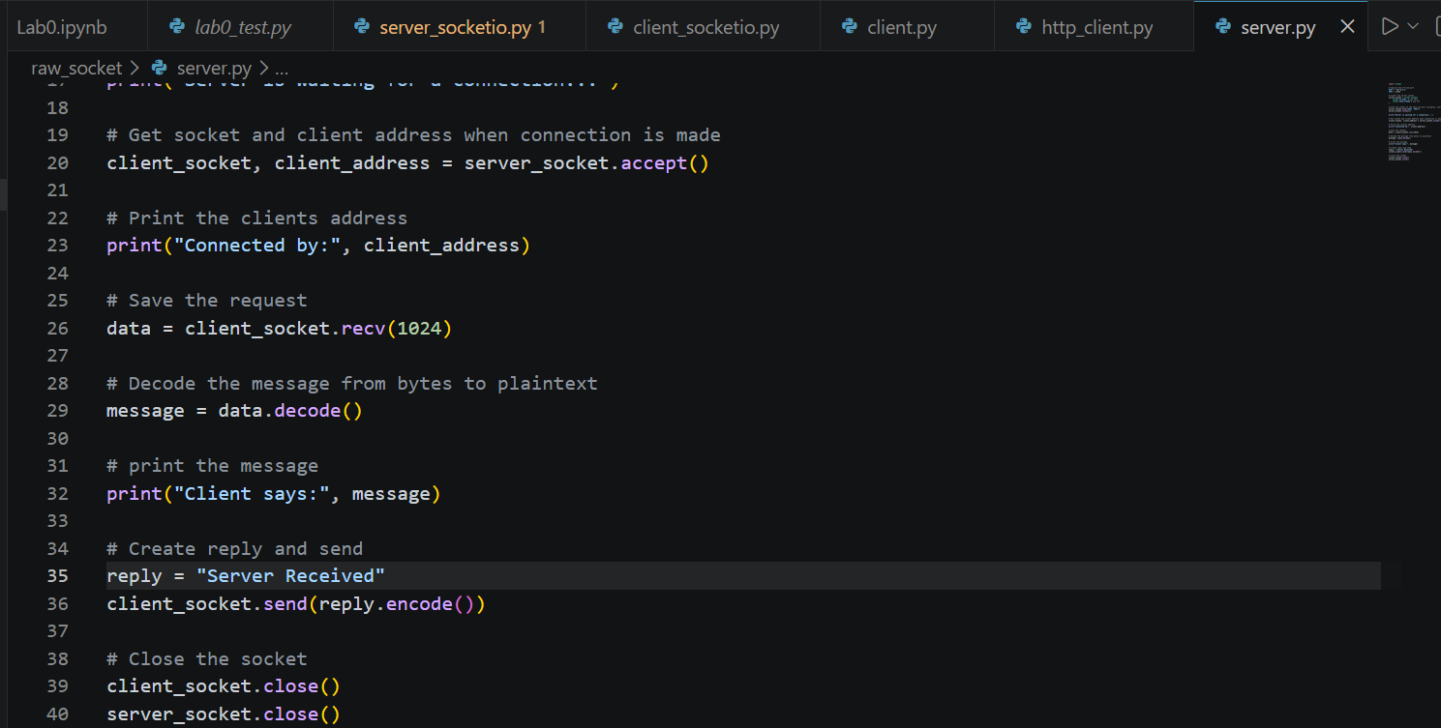
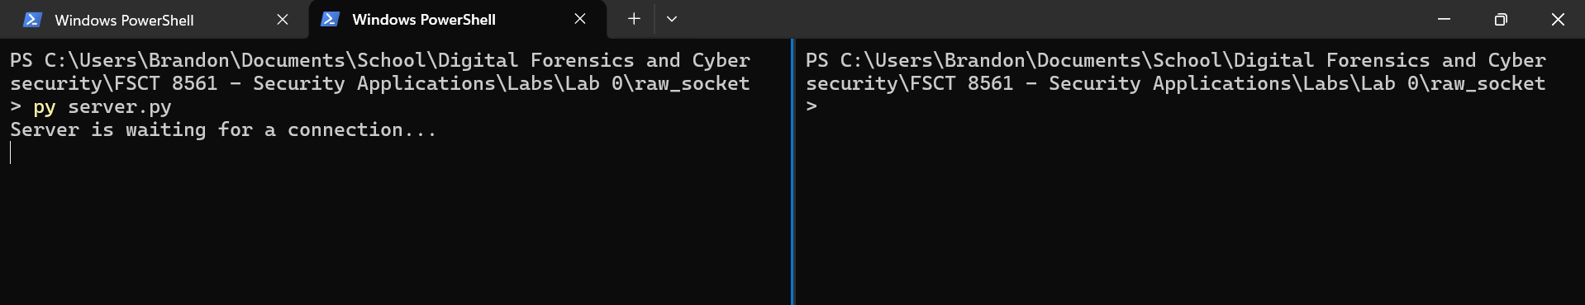

Part 5 — Create a Basic TCP Client
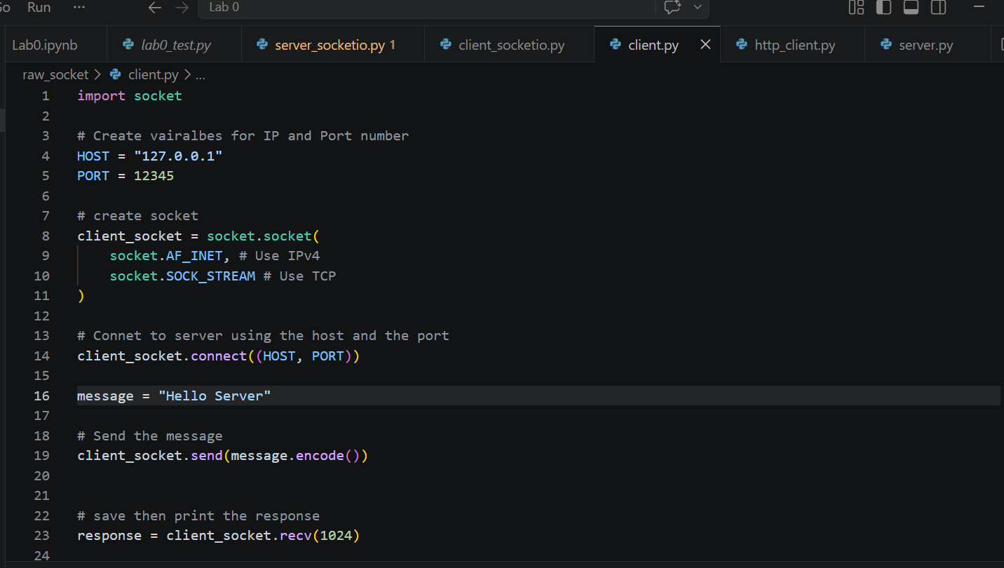
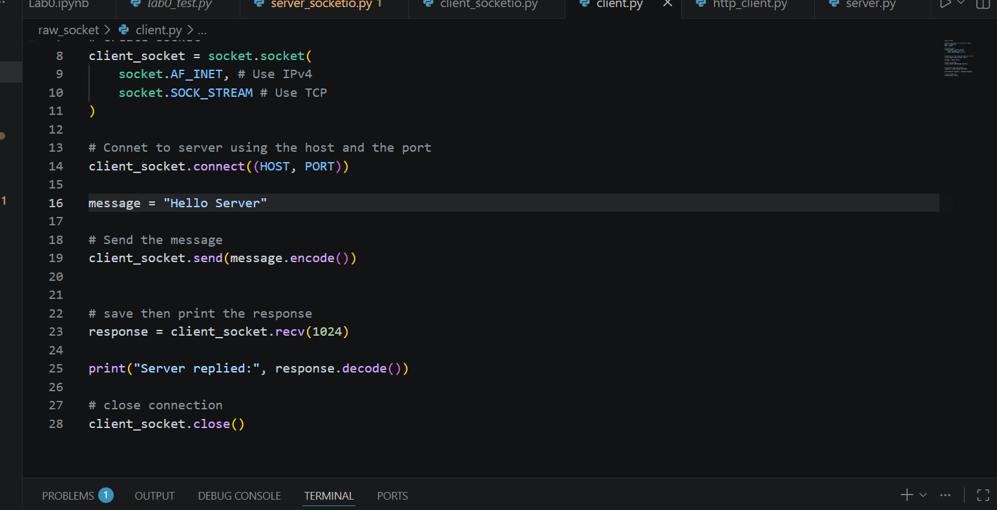
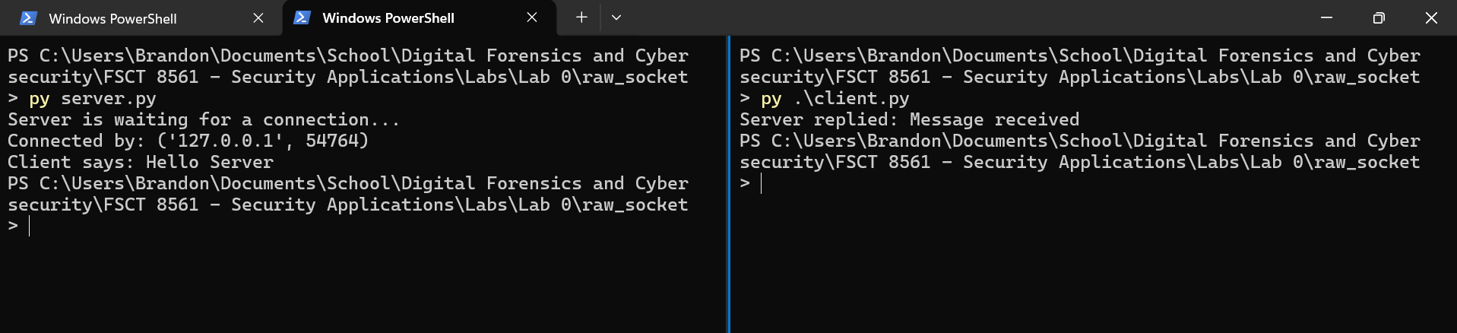

Part 6 — Modify the Client and Server
Client.py
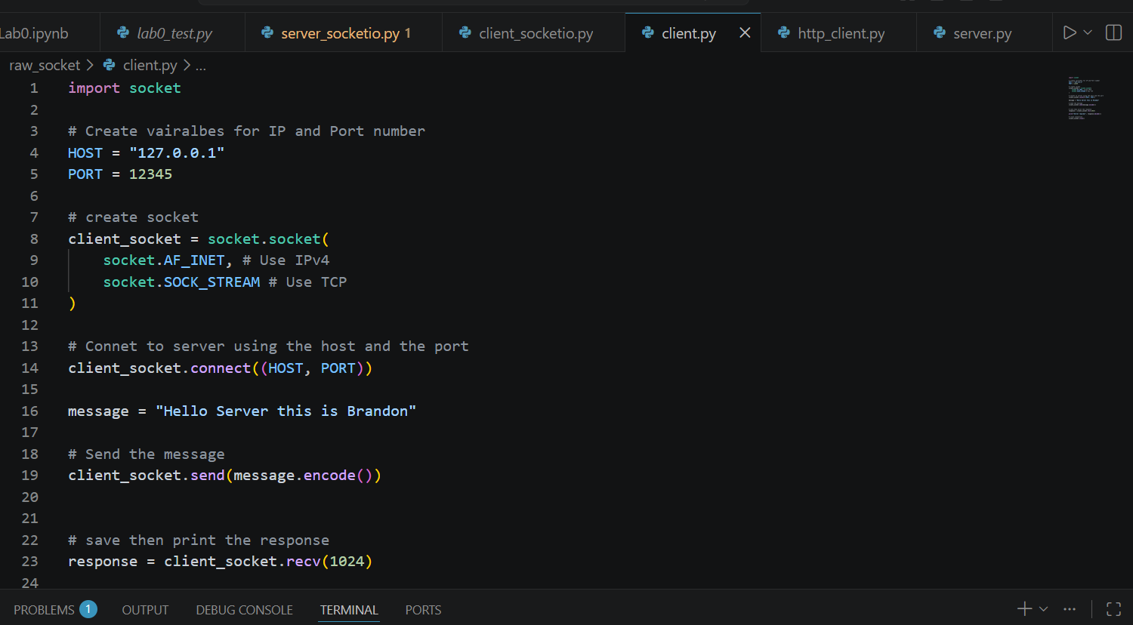
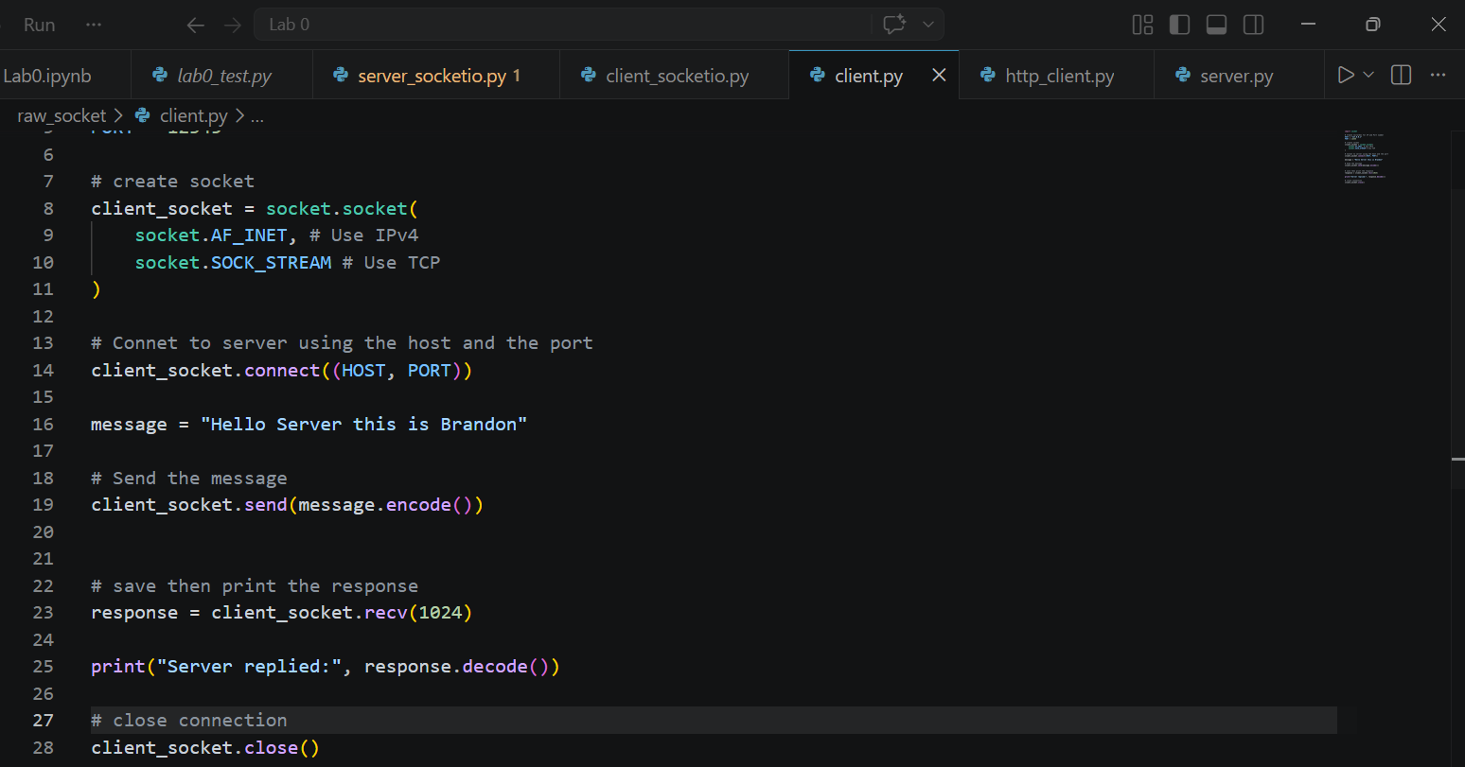

Server.py
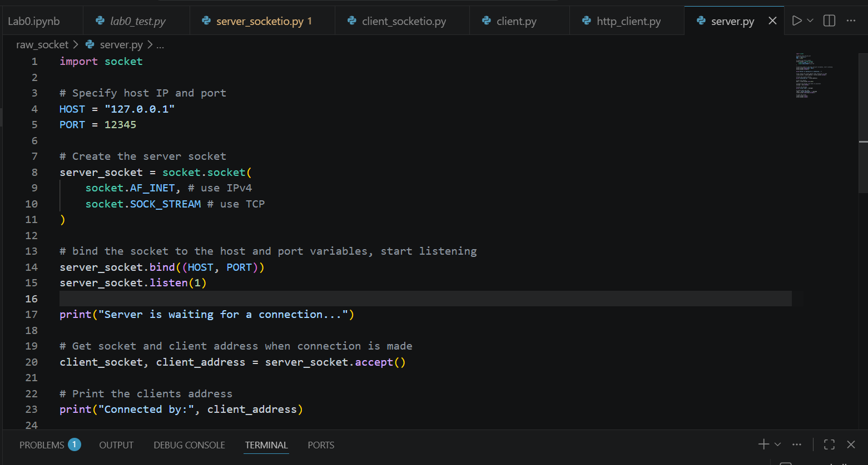
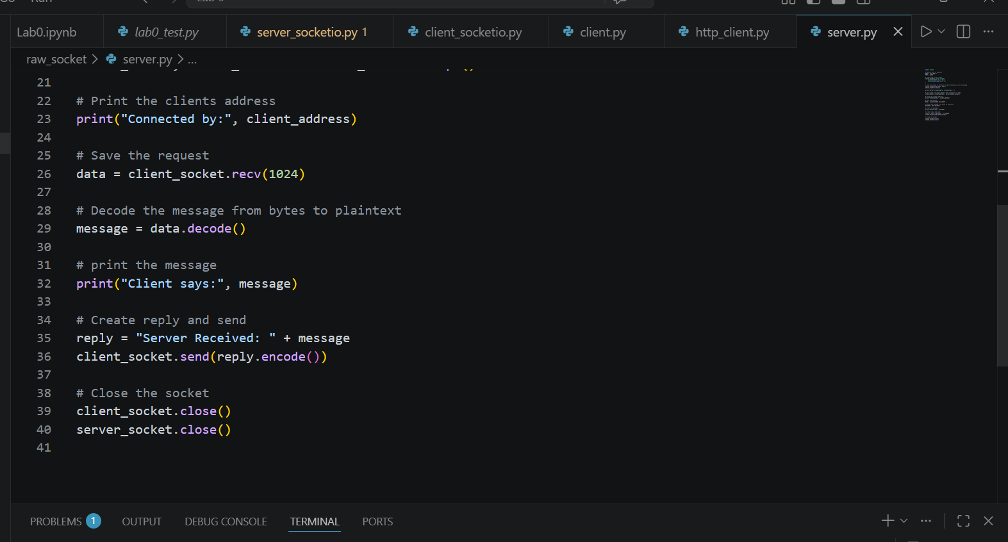

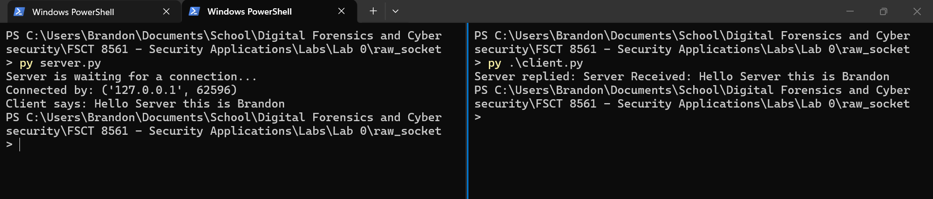

Part 7 — Connect to a Public Web Server
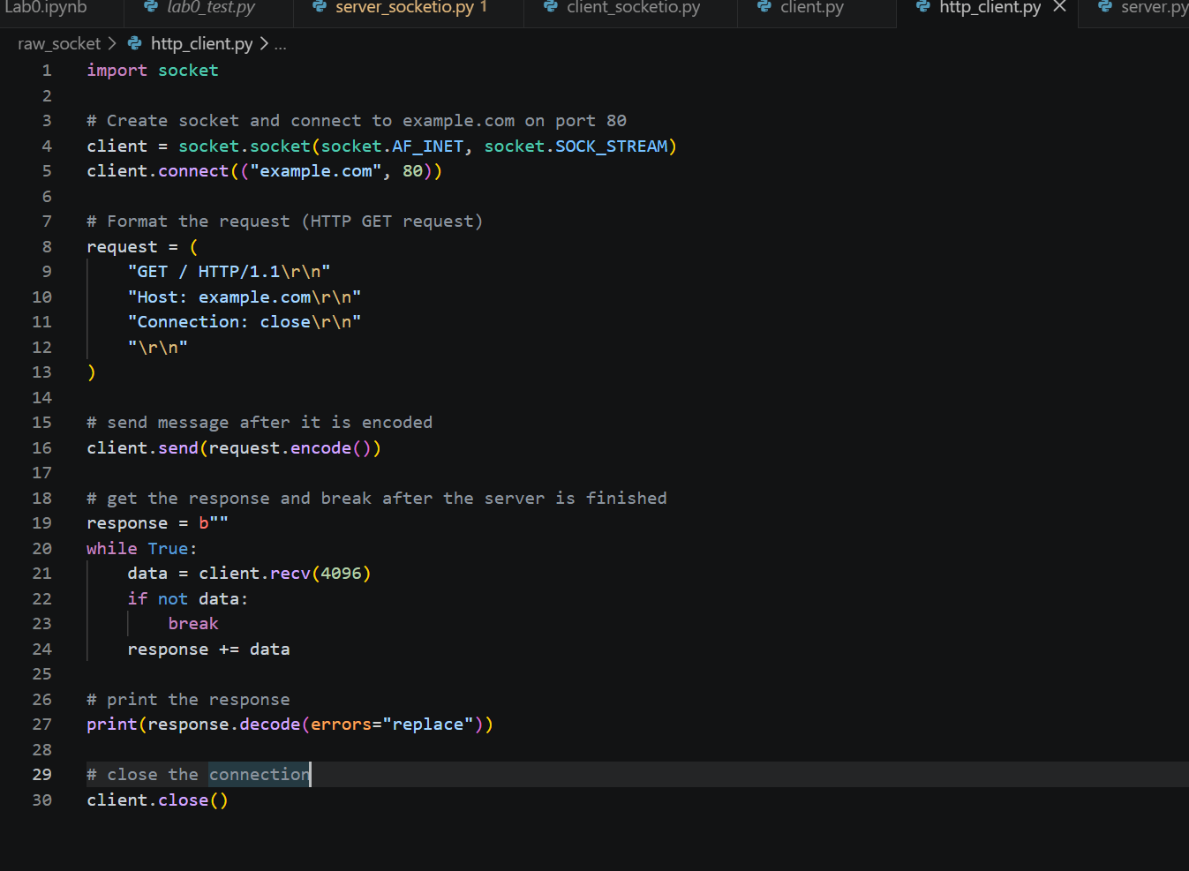
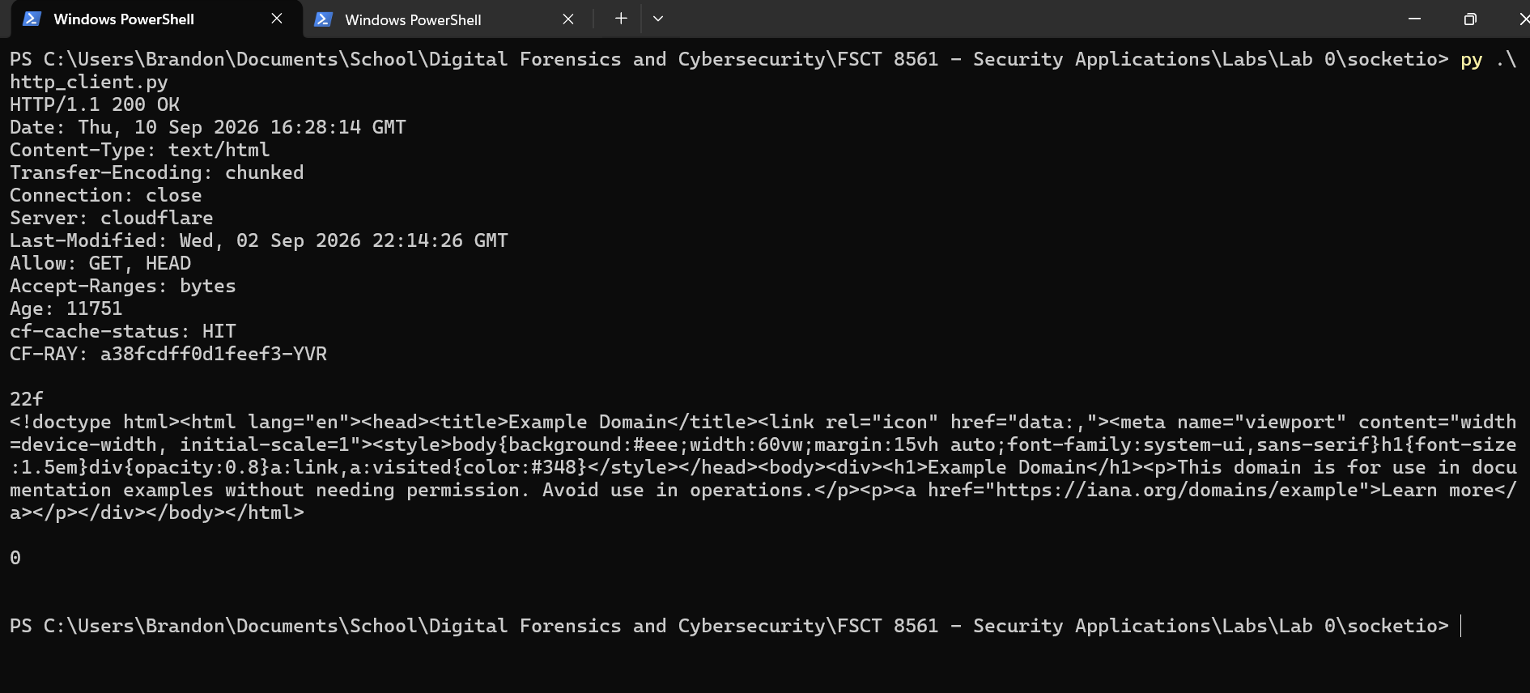

Reflection Question 2
- Which host did the client connect to?
The client connected to example.com
- Which port was used?
Port 80
- Why is port 80 relevant?
It is the designated port for HTTP traffic
- What did the server send back?
It sent an HTML file for the website example.com

Part 8 - Challenge — Rebuild the Client-Server Application Using Socket.IO
Code from: https://python-socketio.readthedocs.io/en/stable/intro.html#what-is-socket-io
Client
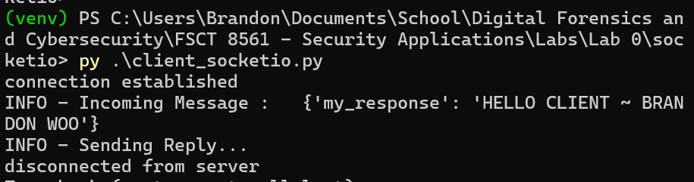
Server:
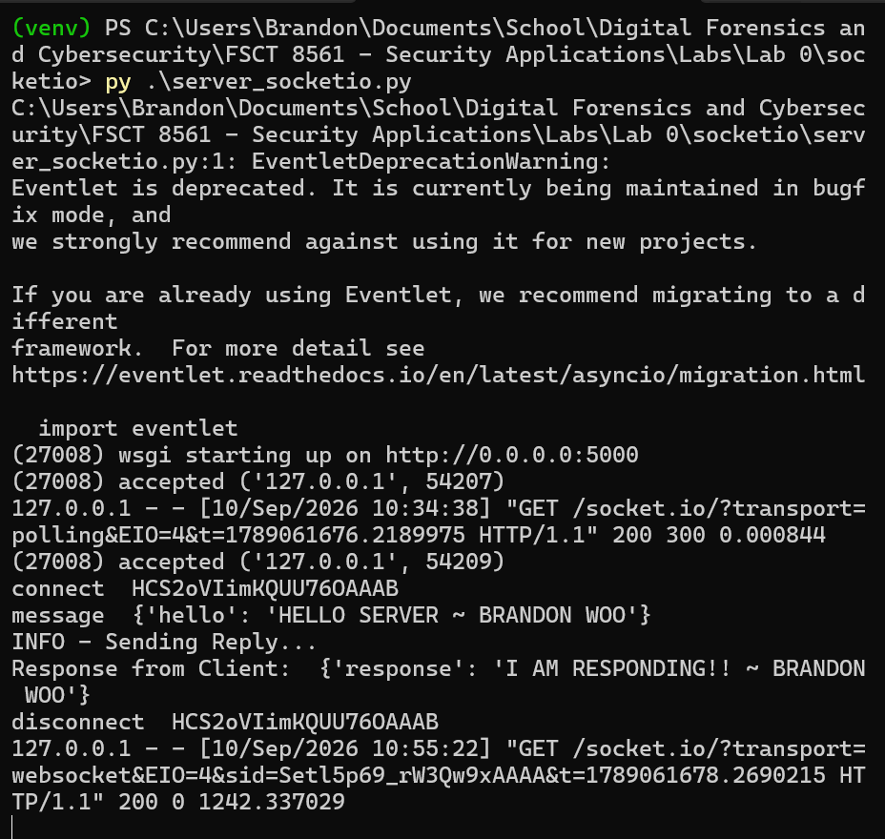

Security Reflection
- What could happen if a server accepts connections from anyone?
It could accept connections from malicious actors that intend to do harm to the server or other people connecting to it
- Is the Lab 0 message encrypted?
No, because the message was sent over HTTP which is not encrypted. To encrypt, it should be sent over HTTPS
- Could network traffic be observed by another system?
Yes, if there was a man in the middle attack, an attacker could read out plaintext messages since they were not encrypted.
- Why should servers validate input?
So that the server can determine if input is malicious. For example, an attacker could perform a SQL injection if data was not validated when it is received
- Why might authentication be useful?
You can keep a list of authenticated clients who are allowed to send messages to the server. If a client fails authentication, the server should deny connections to ensure security.
- Suggest two ways to make this application more secure.
Implement HTTPS for encryption of data as well as authentication to prevent unauthorized clients from connecting to the server.

